III. MEASURES OF CENTRAL TENDENCY

Describing a data series.
What is central tendency?
Mode, median, and mean.
Evaluating skewness.
Grouped frequency distributions.

Describing a Data Series

- Before we jump into our discussion of measures of central tendency, it is important to become familiar with notation that I will use throughout the course.

What Is Central Tendency?

- Measures of central tendency provide a single number that represents the most common or “typical” score around which others in the distribution tend to cluster. They describe the center point in a distribution of scores. Researchers usually have a lot of raw data at their disposal, in some cases thousands or tens of thousands of observations. All of this data is numerical, so a researcher is literally looking at a huge matrix of numbers. For obvious reasons, it is a little cumbersome to refer to an entire data matrix when trying to describe it.

- Three types of central tendency measures are used:
- Mode – most frequently occurring value.
- Median – value in the middle of the distribution.
- Mean – arithmetic average of a distribution.

Mode, Median, and Mean

- The mode is that value or category that occurs with the highest frequency (or highest probability). It is important to keep in mind that the mode is not the highest frequency, but is the category or value associated with the highest frequency.

- With qualitative data, the mode is a category; with quantitative data, the mode is a value.

- Advantages: 1) Simple to compute, and requires no calculations. The analyst simply searches the data series for the most common value. 2) It can be used with all types of data, qualitative or quantitative, and is the only measure of central tendency that can be used with nominal data.

- Disadvantages: 1) Fails to take into account all of the data. It ignores all categories other than the most frequent, and potentially gives a misleading picture of central tendency. 2) It is not very useful with data other than at the nominal and ordinal levels, and is seldom used in practice. This is particularly true with quantitative data where the distribution may be relatively flat.

- The median is the value that divides a distribution of scores exactly in half. It is the middle value, or the 50th percentile. It is a “positional” measure of central tendency that can be used with data at the ordinal level or higher. Other popular positional measures are the deciles and quartiles.

- Advantages: 1) Uses more information than the mode. The median takes into account the position of all of the data values. 2) Not sensitive to extreme scores, thus it is the preferred measure of central tendency with skewed data. Inclusion of outliers does not change values in the middle of the distribution. 3) Can be used with data at the ordinal level or higher. Use of the median only requires that data be rank ordered.

- Disadvantages: 1) Still does not use all of the data available. You are only interested in the value that corresponds to a certain position (the 50th percentile), but you do not take into account the actual values themselves. Thus, the fact that the median is not sensitive to the values in a distribution is both an advantage and disadvantage. 2) Most frequently used statistical techniques rely on the sample mean as a measure of central tendency.

- Calculating the median: 1) Arrange the data in ascending order. 2) Find the position of the median using the formula [(n + 1) / 2]. 3) Count up from the first observation to identify the value (or midpoint of two values) in this position. It is important to remember that the median is the value in the position, not the position itself.

- The mean is the most common measure of central tendency. It represents the arithmetic average of a distribution of scores, which requires data at the ordinal level or higher. The mean is a “balancing” score, meaning that the positive and negative differences from the mean (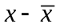) cancel, or balance, each other out. This important property means that 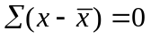.

- Advantages: 1) It has desirable mathematical properties. Among these is the property of “least squares.” 2) It is a stable measure of central tendency. 3) Utilizes all data in the distribution. In other words, the mean uses the values of all of the data points.

- Disadvantages: 1) It is only useful with quantitative (interval, ratio) data. 2) Because it uses all of the data, the mean is sensitive to extreme scores, or outliers. This is especially true when the sample size is small.

- To calculate the mean, you must simply add up all of the values of x and then divide by the number of observations:

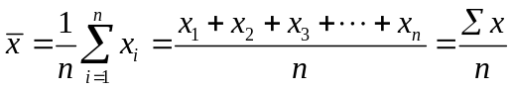

- Let’s consider a couple of examples of central tendency with simple hypothetical data series.

- Data series with n = 15:

1 1 1 2 2 3 4 4 4 4 4 5 5 6 6

The mode in this example is 4, as it has the highest frequency in the data (f = 5). The median is computed by first finding the median position, MP = (15 + 1) / 2 = 8. The value in the 8th position is 4. Note that I could have counted up from the lowest value or down from the highest value and arrived at the same answer for the median. Finally, the mean is calculated as 52 / 15 = 3.47.

- Data series with n = 20:

1 1 2 2 3 3 3 3 4 4 5 6 7 7 8 8 8 8 9 9

In this example, there are actually two modes: 3 and 8, both with f = 4. We would refer to these data as bimodal. The median position is MP = (20 + 1) / 2 = 10.5. Since the value in the 10.5th position is not an integer, we must take the midpoint of the values in the 10th and 11th positions: (4 + 5) / 2 = 4.5. The mean is calculated as 101 / 20 = 5.05.

- When data are in the form of a frequency distribution, we can still compute each measure of central tendency. Consider the following data (n = 50).

Score (x) | f | p | cp | fx
1 | 3 | .060 | .060 | 3
2 | 4 | .080 | .140 | 8
3 | 5 | .100 | .240 | 15
4 | 10 | .200 | .440 | 40
5 | 7 | .140 | .580 | 35
6 | 6 | .120 | .700 | 36
7 | 6 | .120 | .820 | 42
8 | 5 | .100 | .920 | 40
9 | 3 | .060 | .980 | 27
10 | 1 | .020 | 1.000 | 10
 | 50 | 1.000 |  | 256

In this form, the mode is easier to determine. All we must do is find the value or values that have the highest frequency, proportion, or percent. In this case, the mode is 4. The median is also very easy to find with data in a frequency distribution. We do not need to compute the median position first. Rather we simply add an additional column by including the cumulative proportion. To find the median, we simply follow the column down until we encounter the first value that exceeds .500 (or 50%). If a value or category falls exactly at 0.50, this is the median. In our example, the median is 5. Finally, since we observe the raw x-values and their frequencies, we can easily modify the mean formula to reflect this:

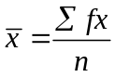

This formula tells us that we must multiply each x-value by its respective frequency, and then sum up the resulting values. This means that we need to add one additional column of data that is the product of the score and its frequency. When we sum up the values in this column, the mean is 256 / 50 = 5.12.

- Now let’s consider measures of central tendency with real data.

- The following table provides a distribution of Index offenses for the State of Maryland in 1999. These are offenses that were reported to police.

Offense | f | p
1 Murder | 465 | 0.002
2 Forcible Rape | 1,151 | 0.005
3 Robbery | 13,636 | 0.054
4 Aggravated Assault | 22,795 | 0.090
5 Burglary | 43,230 | 0.170
6 Larceny-Theft | 147,296 | 0.579
7 Motor Vehicle Theft | 25,447 | 0.100
 | 254,420 | 1.000

- The following table provides information on family living arrangements among a nationally representative sample of youths ages 12 to 16.

 | White Youths |  | Black Youths
Family Living Arrangements | f | p | f | p
1 Both biological parents | 2,743 | .594 | 607 | .263
2 One biological/one step | 706 | .153 | 296 | .128
3 Biological mom only | 864 | .187 | 1,108 | .480
4 Biological dad only | 172 | .037 | 61 | .026
5 Other family member | 136 | .029 | 236 | .102
 | 4,621 | 1.000 | 2,308 | .999

- The following table provides educational attainment among a sample of police officers.

Education Attainment | f | p | cp
Less than HS | 16 | 0.048 | 0.048
HS Grad | 67 | 0.199 | 0.247
Some College | 117 | 0.348 | 0.595
College Grad | 72 | 0.214 | 0.809
Post Grad | 64 | 0.190 | 0.999
 | 336 | 0.999

- The following table provides grades in the 8th grade for male and female youths.

 | Male Youths |  |  | Female Youths
Grades | f | p | cp | f | p | cp
1 A’s and B’s | 1,288 | .293 | .293 | 1,898 | .452 | .452
2 B’s and C’s | 1,714 | .389 | .682 | 1,524 | .363 | .815
3 C’s and D’s | 1,179 | .268 | .950 | 671 | .160 | .975
4 D’s and F’s | 221 | .050 | 1.000 | 109 | .026 | 1.001
 | 4,402 | 1.000 |  | 4,202 | 1.001

- This table compares the number of weekdays spent doing homework among self-report delinquents and non-delinquents. Since the data are measured at the ratio level, we can compute a mean. The means are 10,089 / 2,782 = 3.63 and 7,852 / 2,509 = 3.13 for non-delinquents and delinquents, respectively.

 | Not Delinq. |  |  |  | Delinq.
# Weekdays | f | p | cp | fx | f | p | cp | fx
0 | 233 | .084 | .084 | 0 | 371 | .148 | .148 | 0
1 | 93 | .033 | .117 | 93 | 127 | .051 | .199 | 127
2 | 210 | .075 | .192 | 420 | 260 | .104 | .303 | 520
3 | 488 | .175 | .367 | 1464 | 526 | .210 | .513 | 1578
4 | 678 | .244 | .611 | 2712 | 498 | .198 | .711 | 1992
5 | 1,080 | .388 | .999 | 5400 | 727 | .290 | 1.001 | 3635
 | 2,782 | .999 |  | 10,089 | 2,509 | 1.001 |  | 7,852

- The following table provides a variety scale of the number of six different delinquent acts that a youth reports having ever committed. The mean is computed as 8,924 / 8,934 = 0.999.

# Delinquent Acts | f | p | cp | fx
0 | 4,597 | .515 | .515 | 0
1 | 1,916 | .214 | .729 | 1916
2 | 1,216 | .136 | .865 | 2432
3 | 638 | .071 | .936 | 1914
4 | 279 | .031 | .967 | 1116
5 | 182 | .020 | .987 | 910
6 | 106 | .012 | .999 | 636
 | 8,934 | .999 |  | 8924

- The following data represent sentence length in months for persons convicted of armed robbery (n = 40). The median position is MP = 41 / 2 = 20.5, and the median is (68 + 69) / 2 = 68.5. The mean is 2746 / 40 = 68.65.

36 38 39 47 50 51 51 53 55 55 56 57 60 62 63 64 64 66 67 68
69 70 70 70 71 75 78 79 80 80 81 83 85 86 87 89 95 98 99 99

- The following data represent state-level unemployment for 1998 (n = 50). The median position is MP = 51 / 2 = 25.5, and the median is (4.1 + 4.2) / 2 = 4.15. The mean is 207.1 / 50 = 4.142.

2.4 2.4 2.5 2.5 2.7 2.9 2.9 3.0 3.0 3.0
3.1 3.3 3.4 3.5 3.6 3.6 3.6 3.7 3.7 3.8
3.9 3.9 4.0 4.0 4.1 4.2 4.2 4.2 4.3 4.3
4.3 4.5 4.5 4.6 4.6 4.7 4.8 4.8 4.9 4.9
5.2 5.3 5.3 5.5 5.6 5.7 5.7 5.9 6.3 6.3

- The following data represent rank ordered U.S. homicide rates per 100,000 from 1950 to 2001 (n = 52). The median position is MP = 53 / 2 = 26.5, and the median is (7.4 + 7.9) / 2 = 7.65. The mean is 369.6 / 52 = 7.108.

4.0 4.1 4.1 4.2 4.4 4.5 4.6 4.6 4.6 4.6
4.8 4.8 4.9 4.9 5.1 5.1 5.5 5.6 5.6 5.7
6.2 6.3 6.8 6.9 7.3 7.4 7.9 7.9 8.0 8.2
8.3 8.3 8.4 8.5 8.6 8.7 8.7 8.8 9.0 9.0
9.0 9.1 9.3 9.4 9.4 9.5 9.6 9.8 9.8 9.8
9.8 10.2

- The following data provide homicide rates per 100,000 from 1985 to 1995 for Washington, DC and Baltimore, MD (n = 11).

Yearly
Wash: 23.5 31.0 36.2 59.5 71.9 77.8 80.6 75.2 78.5 70.0 65.2
Balto: 27.6 30.6 29.5 30.6 34.3 41.4 40.6 44.3 48.2 43.4 45.2

Rank Ordered
Wash: 23.5 31.0 36.2 59.5 65.2 70.0 71.9 75.2 77.8 78.5 80.6
Balto: 27.6 29.5 30.6 30.6 34.3 40.6 41.4 43.4 44.3 45.2 48.2

The median position is 12 / 2 = 6, and when rank ordered, the medians are 70.0 and 40.6 for Washington and Baltimore, respectively. The respective means are 669.4 / 11 = 60.85 and 415.7 / 11 = 37.79.

Evaluating Skewness

- With normally distributed or mound-shaped data, the mode, median, and mean will converge on the same value. With skewed data, one of the tails in the distribution is pulled away from the center. With right or positive skew, the right tail is pulled, and with left of negative skew, the left tail is pulled. Specifically, the mean gets pulled away from the median. Recall that this is because the mean is sensitive to outliers, so it will always be pulled in the direction of those outliers.

  - Much of the data that we utilize in criminology and the social sciences in general are skewed (e.g., income, number of accidents, crime rates, number of arrests, sentence length). With skewed data, it is important to report both the median and the mean. This is because the median is usually a better measure of central tendency with skewed data, but the mean is more desirable for statistical inference.

- A useful rule of thumb is that if the mean is greater than the median, there is positive skew in the data. If the mean is less than the median, there is negative skew.

Grouped Frequency Distributions

- When data are in the form of a grouped frequency distribution, you can still obtain measures of central tendency. A disadvantage of grouped data, however, is that we don’t observe the raw values, but rather the interval into which each observation goes. We can partially overcome this disadvantage by resorting to the midpoint of each interval as a “best guess” about where the data lie within the interval. Consequently, the measures of central tendency that we compute with grouped data are only approximations to the actual values.

- The mode is the midpoint (m) of the interval with the highest frequency.

- In order to obtain the median with data in a grouped frequency distribution, you must first locate the interval that contains the median. Do this by identifying the first interval that exceeds a cumulative frequency of (n + 1) / 2 or a cumulative proportion (or percent) of 0.500 (or 50.0%). Then, calculate the approximate value of the median using the formula:

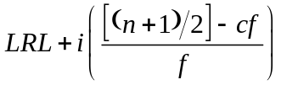

LRL = lower real limit of the interval containing the median.
i = width of the interval based on URL – LRL.
cf = cumulative frequency of the interval below the one containing the median.
f = frequency of the interval containing the median.

- In order to obtain the mean from data in a grouped frequency distribution, we must again modify the mean formula. Instead of observing the raw x’s and frequencies, we observe the midpoints and frequencies. Thus, we will substitute the midpoint m for the x-score.

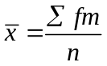

- Let’s consider some examples.

- The following table provides the sentence length in months for armed robbery. The median (interval 4) is 64.5 + 10[(41 / 2) – 17] / 8 = 68.875. The mean is calculated as 2770 / 40 = 69.25.

Interval Limits | Real  Limits | m | f | p | cp | cf | fm
35 – 44 | 34.5 – 44.5 | 39.5 | 3 | .075 | .075 | 3 | 118.5
45 – 54 | 44.5 – 54.5 | 49.5 | 5 | .125 | .200 | 8 | 247.5
55 – 64 | 54.5 – 64.5 | 59.5 | 9 | .225 | .425 | 17 | 535.5
65 – 74 | 64.5 – 74.5 | 69.5 | 8 | .200 | .625 | 25 | 556.0
75 – 84 | 74.5 – 84.5 | 79.5 | 7 | .175 | .800 | 32 | 556.5
85 – 94 | 84.5 – 94.5 | 89.5 | 4 | .100 | .900 | 36 | 358.0
95 – 104 | 94.5 – 104.5 | 99.5 | 4 | .100 | 1.00 | 40 | 398.0
 |  |  | 40 | 1.000 |  |  | 2770.0

- The following data provide state-level unemployment rates in 1998. The median (interval 4) is 3.95 + 0.5[(51 / 2) – 22] / 9 = 4.144. The mean is calculated as 206.6 / 50 = 4.132.

Interval Limits | Real  Limits | m | f | p | cp | cf | fm
2.0 – 2.4 | 1.95 – 2.45 | 2.2 | 2 | .040 | .040 | 2 | 4.4
2.5 – 2.9 | 2.45 – 2.95 | 2.7 | 5 | .100 | .140 | 7 | 13.5
3.0 – 3.4 | 2.95 – 3.45 | 3.2 | 6 | .120 | .260 | 13 | 19.2
3.5 – 3.9 | 3.45 – 3.95 | 3.7 | 9 | .180 | .440 | 22 | 33.3
4.0 – 4.4 | 3.95 – 4.45 | 4.2 | 9 | .180 | .620 | 31 | 37.8
4.5 – 4.9 | 4.45 – 4.95 | 4.7 | 9 | .180 | .800 | 40 | 42.3
5.0 – 5.4 | 4.95 – 5.45 | 5.2 | 3 | .060 | .860 | 43 | 15.2
5.5 – 5.9 | 5.45 – 5.95 | 5.7 | 5 | .100 | .960 | 48 | 28.5
6.0 – 6.4 | 5.95 – 6.45 | 6.2 | 2 | .040 | 1.00 | 50 | 12.4
 |  |  | 50 | 1.00 |  |  | 206.6

Table XX: Number of Days Free before Re-arrest

Raw Data (n = 40)

19 27 30 34
20 27 31 34
23 28 31 35
23 28 31 36
24 28 32 37
25 29 32 37
25 29 33 38
26 29 33 39
26 29 33 39
27 30 33 40

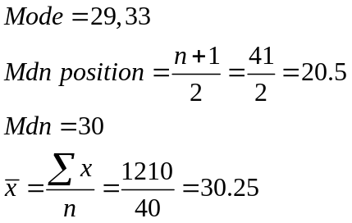

Grouped Frequency Distribution

Stated Limits | Real Limits | Midpoint | Frequency | fm
19 – 22 | 18.5 – 22.5 | 20.5 | 2 | 41.0
23 – 26 | 22.5 – 26.5 | 24.5 | 7 | 171.5
27 – 30 | 26.5 – 30.5 | 28.5 | 12 | 342.0
31 – 34 | 30.5 – 34.5 | 32.5 | 11 | 357.5
35 – 38 | 34.5 – 38.5 | 36.5 | 5 | 182.5
39 – 42 | 38.5 – 42.5 | 40.5 | 3 | 121.5
 |  |  | 40 | 1216.0

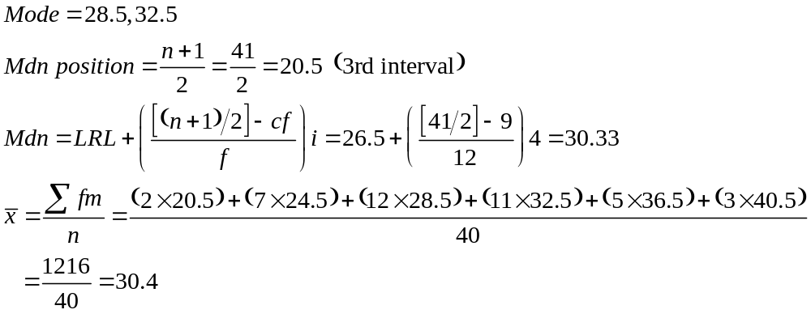

Table XX: Scores on a Police Officer Competency Test

Raw Data (n = 25)

10 11 14 15 16
10 11 14 15 16
10 11 15 15 19
10 13 15 15 20
10 13 15 16 20

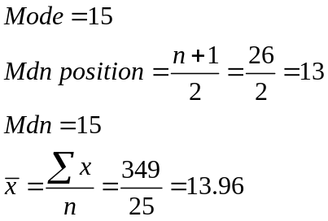

Ungrouped Frequency Distribution

Score (x) | f | fx
10 | 5 | 50
11 | 3 | 33
12 | 0 | 0
13 | 2 | 26
14 | 2 | 28
15 | 7 | 105
16 | 3 | 48
17 | 0 | 0
18 | 0 | 0
19 | 1 | 19
20 | 2 | 40
 | 25 | 349

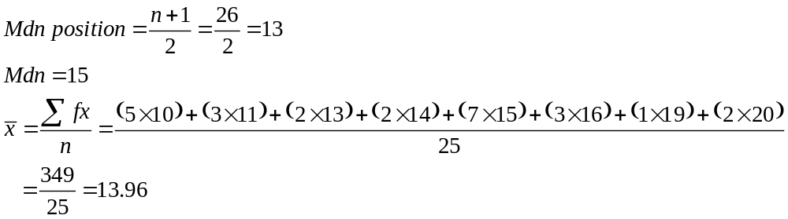

Table XX: Rate (per 100,000) of Forcible Rape by State, 1999 (UCR, 2000)

Raw Data (n = 51)

17.3 26.3 28.7 36.8 44.0
18.6 26.9 28.9 37.8 45.8
19.1 27.0 29.8 38.0 46.3
19.6 27.2 29.9 39.5 47.1
19.9 27.3 30.0 40.1 47.8
20.1 27.8 33.1 40.8 49.2
22.4 28.2 33.3 40.9 52.1
22.9 28.2 34.2 41.4 54.3
24.8 28.3 34.6 41.7 70.2
25.0 28.5 36.7 42.7 83.5
26.3

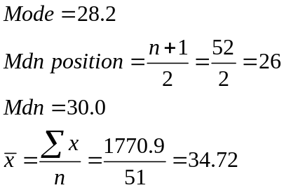

Grouped Frequency Distribution

Stated Limits | Midpoint | f | fm
15.0 – 23.9 | 19.45 | 8 | 155.60
24.0 – 32.9 | 28.45 | 18 | 512.10
33.0 – 41.9 | 37.45 | 14 | 524.30
42.0 – 50.9 | 46.45 | 7 | 325.15
51.0 – 59.9 | 55.45 | 2 | 110.90
60.0 – 68.9 | 64.45 | 0 | 0.00
69.0 – 77.9 | 73.45 | 1 | 73.45
78.0 – 86.9 | 82.45 | 1 | 82.45
 |  | 51 | 1783.95

